Station #1: War Crimes Trials

When World War 2 came to an end the Allied Powers decided to punish enemy leaders who committed terrible crimes during the war. They held war crimes trials to determine what crimes had been committed and who was responsible. Many German and Japanese leaders were executed for their actions during the war.

What is a war crime? At first you may think that there are no laws where war is concerned. Each side is trying to kill each other so anything goes. However, the world has established that some things are not okay even during war. These rules are put forth in agreements such as the Geneva Convention. Actions that are considered war crimes include actions such as killing or mistreating prisoners of war, killing civilians, bombing cities and towns with no military objective, and killing hostages. During World War II many countries violated these basic laws of war. There were also "crimes against humanity" like the Holocaust in Germany. Hermann

Perhaps the most famous war trials held after World War 2 were the Nuremberg Trials. These trials took place in the German city of Nuremberg and looked to punish 23 of the most powerful Nazi leaders for the crimes they committed during the war. The men on trial included Martin Bormann (Hitler's private secretary), Hermann Goring (Head of the Gestapo), and Rudolf Hess (Deputy Fuhrer). Twelve of these men were found guilty and sentenced to death.

T The Tokyo Trials were held in Tokyo, Japan and brought charges against many of the Japanese leaders during the war. The most famous leader brought to trial was Japanese Prime Minister Hideki Tojo who was found guilty of several crimes and was executed. The Tokyo Trials lasted for three years. The Emperor of Japan, Hirohito, was not put on trial. He was allowed to continue as a figurehead by General MacArthur in order to maintain peace and stability in Japan.

Several other trials were held throughout the world. In Germany, trials were held at many of the German concentration camps punishing the leaders and doctors who ran the camps. In China there were multiple trials held including the Nanjing War Crimes Trail to punish those responsible for the Nanjing Massacre.

Several Nazi leaders including Adolf Hitler and Heinrich Himmler were not put on trial because they committed suicide at the end of the war. The Nuremberg Trials were called "the greatest trial in history" by one of the British judges. Several Nazi doctors were put on trial for crimes against humanity including the mass killings of people based on race as well as the handicapped. They also conducted medical experiments on people. Some Nazi war criminals were able to escape to other countries and remain hidden for years. People known as "Nazi Hunters" spent much of their lives tracking the criminals down in hopes of bringing them to justice.

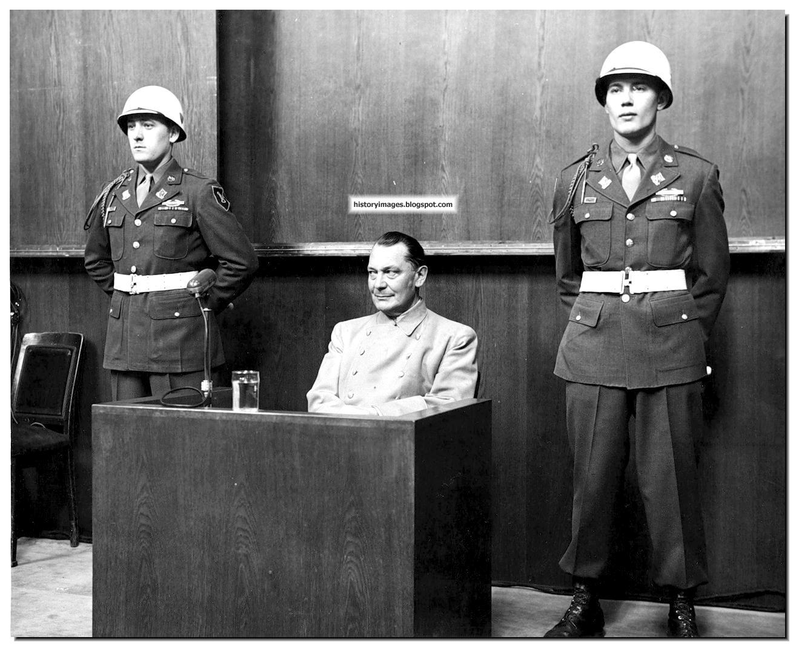
Hermann Goering, head of the Gestapo (the Nazis’ secret police force) on trial at Nuremberg (1946)

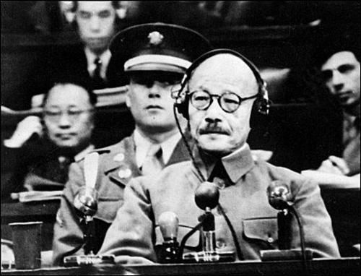
General Hideki Tojo, Prime Minister of Japan, on trial in Tokyo (1948)

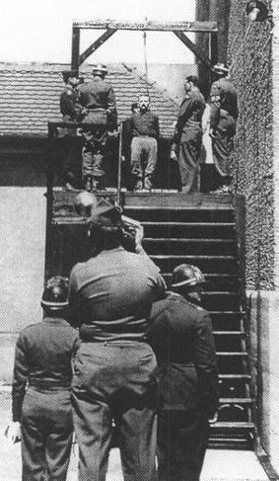
Nazi officer about to be executed by hanging at Landsberg, another trial site in Germany

Station #2:
The Yalta Conference

The Yalta Conference was a WW2 wartime meeting, held over a period of eight days from February 4, 1945 - February 11, 1945, between the United States, Great Britain and Russia. The Yalta Conference was led by the 'Big Three' heads of government consisting of Franklin D. Roosevelt, Winston Churchill and Joseph Stalin. The war in Europe was nearly over and the purpose of the Yalta Conference was to discuss the unconditional surrender and occupation of Nazi Germany, the defeat of Japan and peace plans for the post war world.

What was decided at the Yalta Conference? Summary and Agreements of the Conference
A summary of what happened at the Yalta Conference, the agreements and what was decided:
- Poland: A government of 'national unity' to be set up in Poland, comprising both communists and non-communists established by free elections
- The Declaration of Liberated Europe with free elections in the countries of eastern Europe
- The unconditional surrender of Germany: Germany would be split into four zones of occupation (the United States, Great Britain, the Soviet Union and France) and pay war reparations
- Russia was invited to join the United Nations and would fight in the war against Japan when Germany was defeated
Yalta Conference Significance
Several agreements and promises made during the Yalta Conference were broken which led to tensions between Britain, the United States and Russia and the start of the Cold War.
- Two weeks after the Yalta Conference the Soviets violated the Declaration of Liberated Europe by pressurizing the King of Romania to appoint a Communist government
- Stalin had arrested the non-communist leaders of Poland and the Soviets refused to allow more than 3 Non-Communist Poles to serve in the 18 member Polish Government
- The promise of free elections in Eastern Europe was being broken and Communists were coming to power in other Eastern European countries
- The Soviets began to demand unreasonable war reparations from Germany
- The broken promises led to growing distrust of the Soviets and strong Anti-Communist sentiments
- These events all contributed to the causes of the Cold War
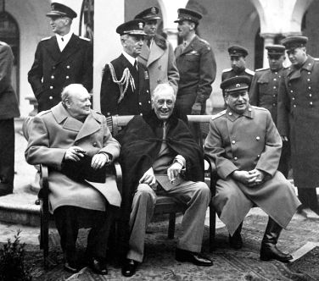

Left to right: Winston Churchill, Franklin D. Roosevelt, and Josef Stalin at the Yalta Conference

Station #3:
The United Nations

Preamble of the United Nations Charter
The Charter of the United Nations was adopted at the San Francisco Conference of 1945.
We the peoples of the United Nations determined to save succeeding generations from the scourge of war, which twice in our lifetime has brought untold sorrow to mankind, and
To reaffirm faith in fundamental human rights, in the dignity and worth of the human person, in the equal rights of men and women and of nations large and small, and
To establish conditions under which justice and respect for the obligations arising from treaties and other sources of international law can be maintained, and
To promote social progress and better standards of life in larger freedom, and for these ends
To practice tolerance and live together in peace with one another as good neighbors, and
To unite our strength to maintain international peace and security, and
To insure, by the acceptance of principles and the institution of methods, that armed force shall not be used, save in the common interest, and
To employ international machinery for the promotion of the economic and social advancement of all peoples, have resolved to combine our efforts to accomplish these aims.
Accordingly, our respective Governments, through representatives assembled in the city of San Francisco, who have exhibited their full powers found to be in good and due form, have agreed to the present Charter of the United Nations and do hereby establish an international organization to be known as the United Nations.

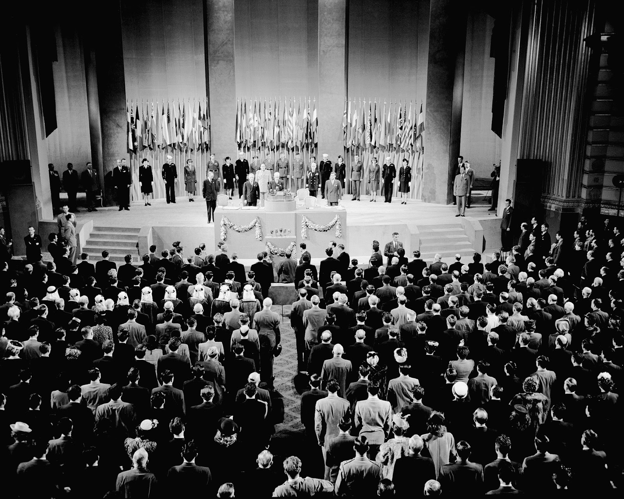

Delegates from each of the member nations at the United Nations Conference in San Francisco, where the U.N. charter was drafted and signed (October 1945)

Station #4:
Truman Doctrine

The Truman Doctrine derives from a speech made to Congress on March 27, 1947 by President Harry Truman. The Truman Doctrine pledged to support other countries in their struggle to resist communism. The key element of the Truman Doctrine was the policy of containment. Containment was the policy of restricting communist expansion by diplomatic, military and economic actions. The Truman Doctrine warned that it was the duty of the United States to quash the communist aggression in Turkey and Greece. The purpose of the Truman Doctrine were to ease the USSR demands in Turkey and to stabilize the government in Greece to prevent the spread of communism.

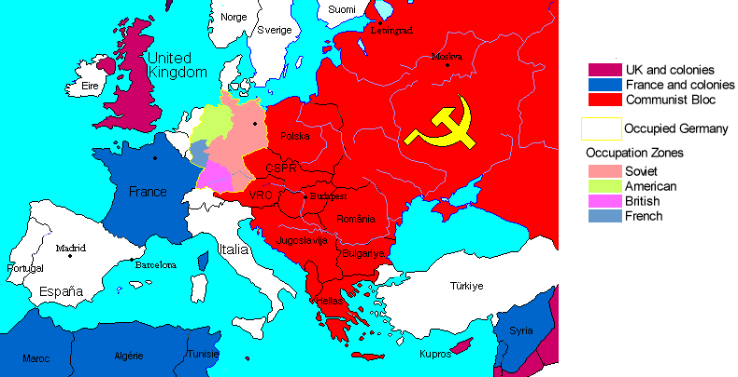

Map of Europe following WWII (Communist nations shown in red)

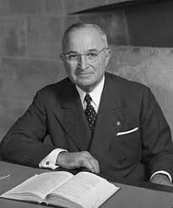
Harry S. Truman (1884-1972), 33rd President of the United States and FDR’s successor

Station #5:
Marshall Plan

The Marshall Plan, officially the European Recovery Program (ERP), was proposed by US Secretary of State George C. Marshall in June 1947. The Marshall Plan followed President Truman's speech to Congress and can be termed "Truman Doctrine - Phase II". The Marshall Plan was devised in response to the economic ruin and political chaos in many European countries following WW2. The Marshall Plan was a US-financed relief package, providing funds to European nations to assist their reconstruction after the devastation of WW2. The Mutual Defense Assistance Act, aka the Military Marshall Plan, was passed by US Congress in October 1949 authorizing the US government to supply equipment, military aid and support to nations at risk from communism. The Marshall Plan was essential for the success of the US policy of containment.

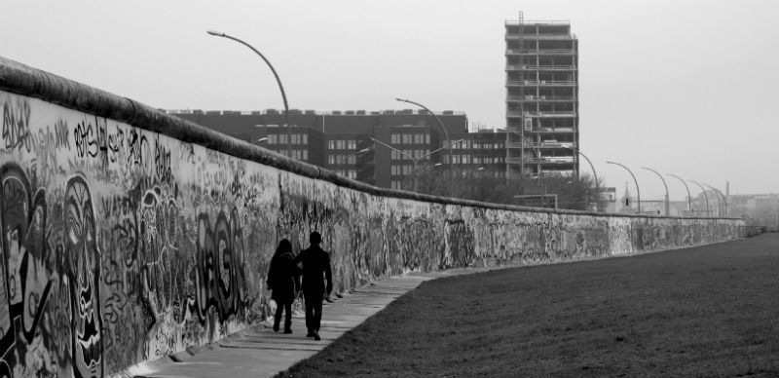
The Berlin Wall, which separated U.S. occupied West Germany from Communist East Germany, and became a physical symbol of Cold War tensions between the U.S. and Soviet Union.

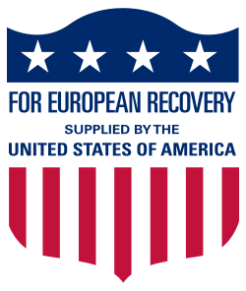
Propaganda in support of the Marshall Plan

